Beef & Stout Stew

Serves 2/3 or1 with leftovers for one or two nights
Stewing Beef of your choice – 300-400g
1 onion
1 carrot
Any vegetables you like
1tsp garlic puree or minced garlic
Irish Stout – Preferably a Cork brand brewed in Cork since 1856!!
Prune Juice
Rich Beef Stock Cubes

You will also need the store cupboard items: Oil, Salt, Pepper

The Stew
Stew is a family favourite, and something everyone has their own recipe for. This version is something quite different. The flavours are quite unique, a recipe inspired by Marco Pierre White, the use of Prune Juice adds incredible dept of flavour to this dish. It is quite simple to prepare; all it needs is time. If you have a slow cooker this is perfect for it, I don’t, I use a trusty cast iron dutch oven, and a nice low temperature oven for hours on end. I have been known to leave this cooking for 24hours!
The key of the preparation is colour. You will see in the video that the prep is quite easy, but you need to put a little effort in to the cooking at the start.
Method:
The choice of beef is up to you, you could buy a cheap joint and cut it into big chunks, that is my preference, or you could buy diced steak, you can buy ‘stewing’ steaks, not matter what you choose, or what size you choose it doesn’t really matter as long as you pick a size and go with it.
You need to sear the beef, on all sides, as well as you can in a very hot pan. There is a huge difference between browned meat and seared meat. In the picture, on the left is browned meat, it is just cooking, on the right is well seared meat, the left is what you need.
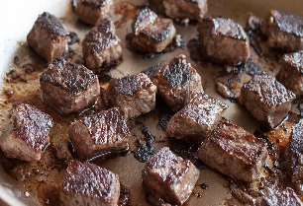
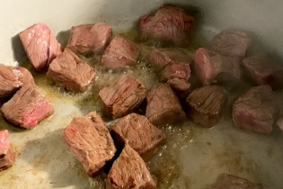
All that colour, all that caramelisation, that is flavour that you need in the stew, likewise the ‘burnt’ bits at the bottom, we will use them, don’t throw it away. Do it in batches if you need to.
Chop your vegetables, again size and variation is your choice, any root vegetables will work. Again, fry the vegetables in the same pan, batches if necessary. Put meat and vegetables back into the pan you are going to cook it in.
Put a tumbler of stout and prune juice, just cover meat and vegetables, into the pan you cooked the beef in and bring to the boil, scrape the bottom of the pan to release all the burnt-on bits, called a fond. Crumble in 1-2 stock cubes.
Place in an oven and cook for a minimum of 4 hours at 150 degrees, or 130 degrees for 6 hours or reduce to 110 degrees for anything from 8 up to 24 hours. At the end of cooking, the sauce should be only slightly reduced but the meat should be meltingly tender. You can thicken the sauce with cornflour to your desired thickness, but I recommend only add a little, it should just give it a little body but should still be quite a loose sauce, cornflour affects flavour also, so perhaps if you are inclined to want a thicker sauce, cook your potatoes in the stew like you would a traditional stew.

The Mash:
I always serve this stew with mash, but you can do steamed, boiled, cooked in the sauce. Everyone has their own way of making mash, but again convenience often leads me to the readymade mash, I don’t mean the instant one, the mash that is in a tub that is literally cold mashed potato. To lift the mash to a homemade standard, break it up with a fork, add salt and butter, and microwave until hot throughout, when you mix it, it may become oily, so thin out with some milk, honestly you won’t know the difference, its lump free, delicious mash, in an instant.
Chef’s Tip: If you are inclined, you can fry some bacon lardons, and fry some shredded kale to top the stew but that is optional.

To Plate:
Place a nice big scoop of mash on one side of the bowl, carefully ladle in the stew. Top with fried lardons and crispy kale.

What to do with leftovers:
Leftover stew will freeze well, but it will also work well as a 2 to 3-night meal. Leftover mash can be used in fishcakes that we have a recipe for, or use them in soup, or if you are feeling adventurous use it for some gnocchi.

