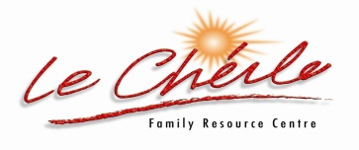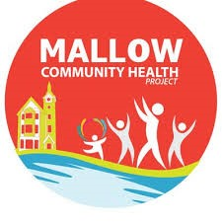
Mallow Community Health Project in collaboration with Le Cheile Family Resource Centre is offering two 6 weeks free Chair Yoga classes.
Venue: Le Cheile FRC Underground Car Park.
Time : 2 pm -3 pm
Start Dates : Monday 17th & Wednesday the 19th January 2022

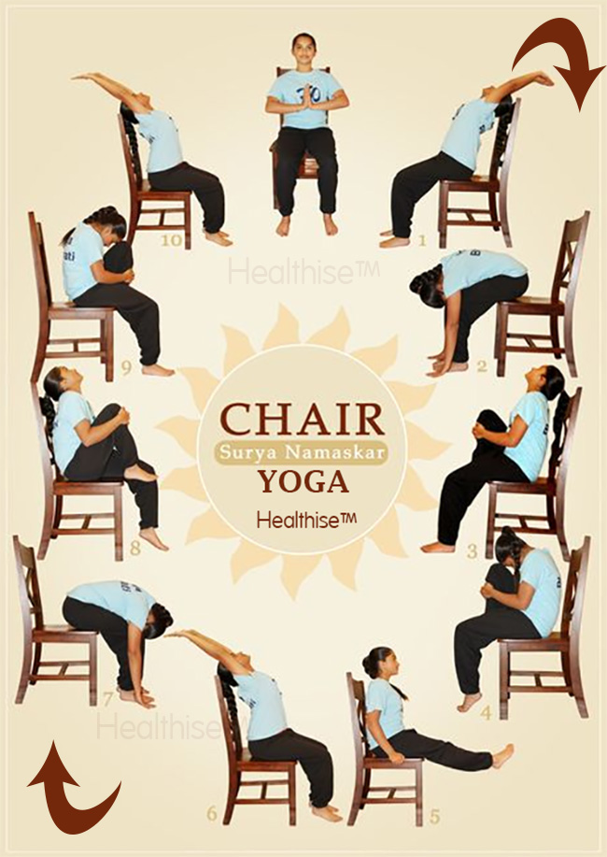

Please contact Community Health Worker, Pauline: if you would like to register for these classes. Phone: 087-4335047, Email: chp@lecheilefrc.ie

