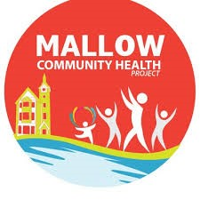

Grovey Movers :
Mallow Community Health Project is offering 6 weeks’ free exercise classes to music.
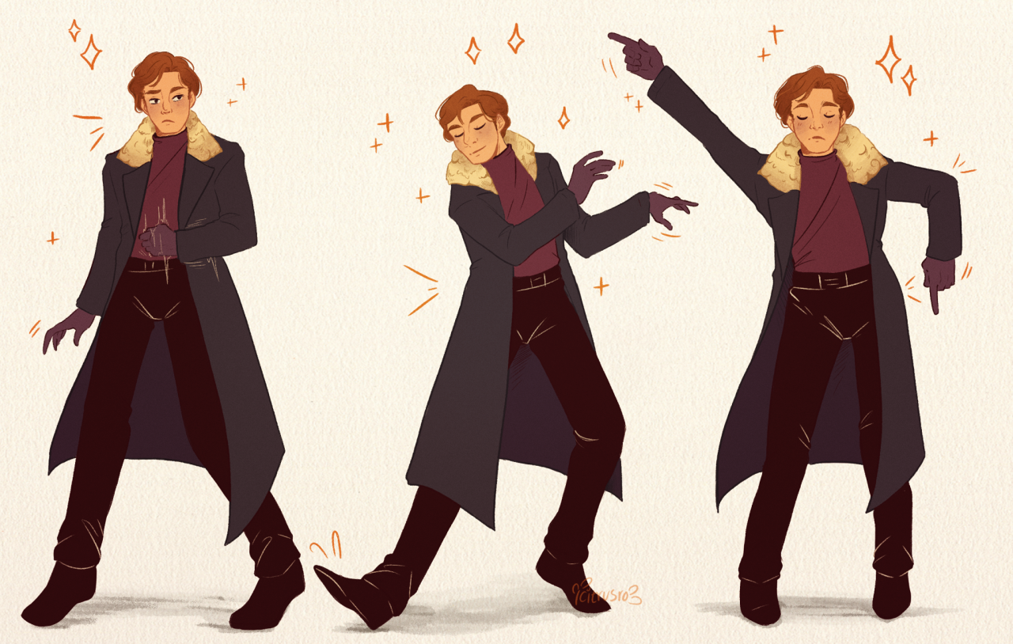
Commencing : Wednesday 27th April
Venue: Le Cheile Underground Car Park
Time: 11 am to 12 mid day
Tutor: Shirley Langford
Please contact , Pauline O Grady-Noonan, Community Health Worker: Mallow Community Health Worker: chp@lecheilefrc.ie. OR, Phone: 087-4335047 to register.

