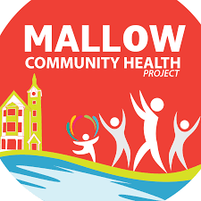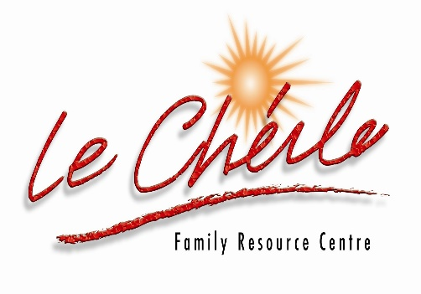

6 WEEKS CHAIR YOGA
Mallow Community Health Project
is offering 6 weeks Chair Yoga.

€20 for 6 WEEKS
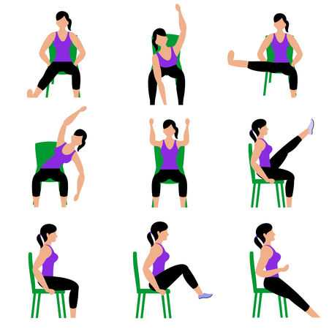
Commencing: Tuesday, 14th June – Tuesday 19st July 2022
Venue: Le Cheile Underground Car Park
Time: 11 am – 12 mid-day
Who to contact: Please contact Mallow Community Health Worker, Pauline Grady-Noonan 087-4335047 OR Email: chp@lecheilefrc.ie



