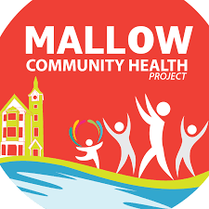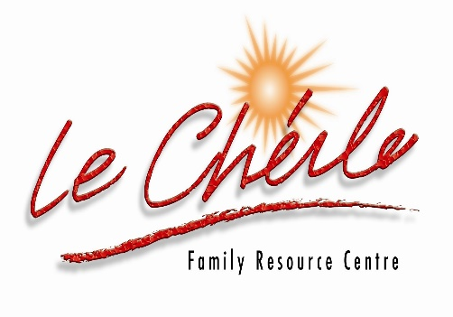

6 WEEKS CHAIR YOGA
Mallow Community Health Project
is offering 6 weeks Chair Yoga.

€20 for 6 WEEKS
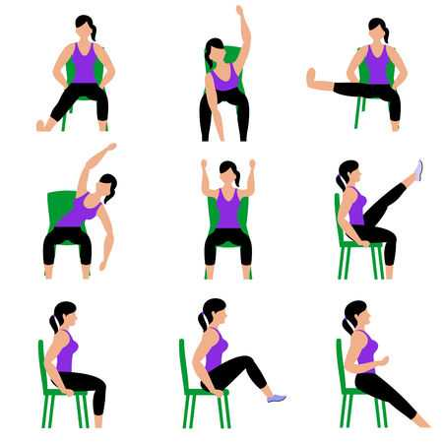
Commencing: Wednesday, 1st June 2022
Venue: Le Cheile Underground Car Park
Time: 1pm- 2 pm
Who to contact: Please contact Mallow Community Health Worker, Pauline Grady-Noonan 087-4335047 OR Email: chp@lecheilefrc.ie



