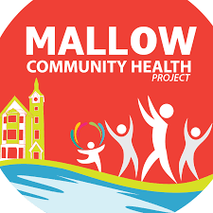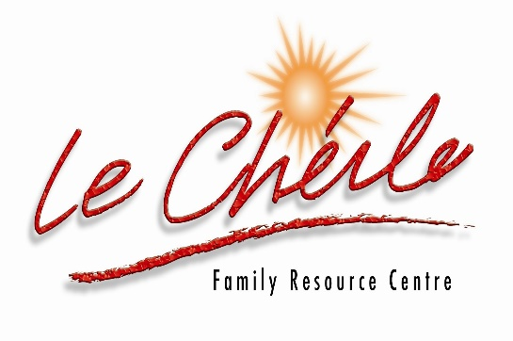
Mallow Community Health Project in collaboration with Diabetic Nurse /Public Health Nurse are offering free HEALTH CHECKS.
Date: Wednesday 1 st June 2022
Venue: Co Op Superstores, Park Road, Mallow.
Time: 10 am – 12 mid-day

Men’s Health Checks:

An invitation to all men in Mallow and the surrounding areas to come and get a free Health Check with Community Diabetic Nurse and 2 Public Health Nurses.
These Nurses will educate you in all things healthy, and answer your queries and concerns regarding a healthy life style.
Join us: Dairygold Co Op, Park Road, Mallow
Wednesday the 1st June, from 10 am – 12 mid-day.

Pre-Booking required for this event
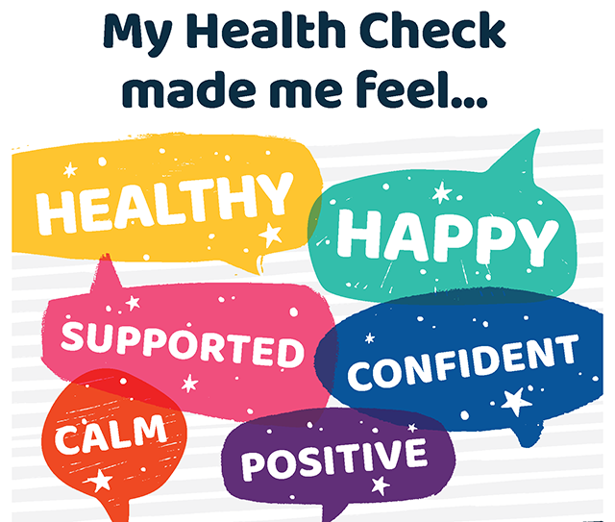

Please contact: Mallow Community Health Worker, Pauline O Grady-Noonan if you have any queries regarding this event.
Phone: 087- 4335047, Email: chp@lecheilefrc.ie


