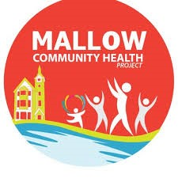

Groovy Movers:
Mallow Community Health Project is offering 4 weeks’ exercise classes to music.
€15 for 4 WEEKS
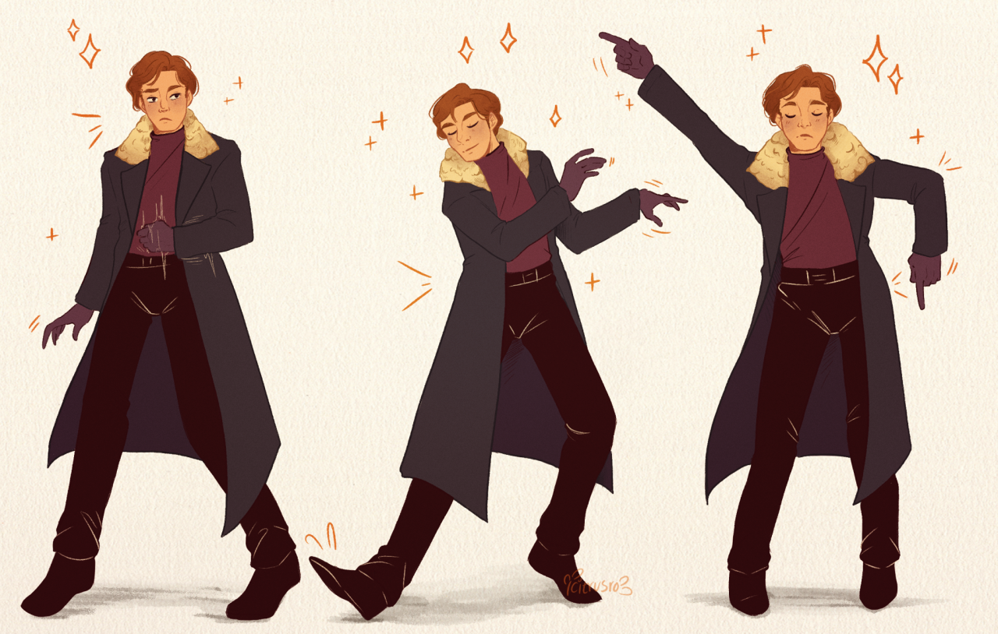
Commencing : Wednesday 6th July
Venue: Le Cheile Underground Car Park
Time: 2 pm – 3 pm
Tutor: Shirley Langford
TO REGISTER : Please contact , Pauline O Grady-Noonan, Community Health Worker: Mallow Community Health Worker: chp@lecheilefrc.ie. OR, Phone: 087-4335047

