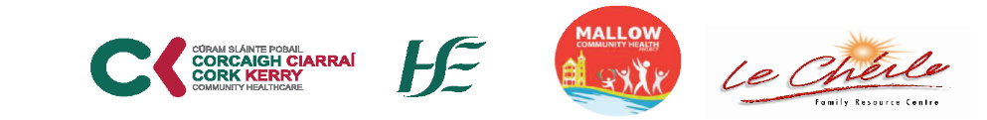
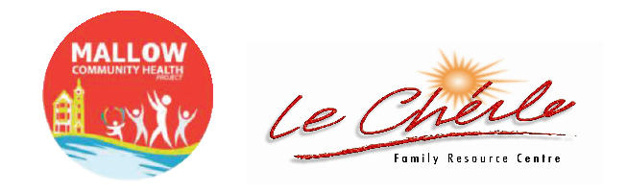


Yoga at the Castle: Health Month 2022
Four (4) Week Programme; Commencing:
Tuesday : 4th , 11th, 18th and 25th October.
Venue: Mallow Castle Grounds
Time: 10 am – 11 am
€20 for 4 Weeks
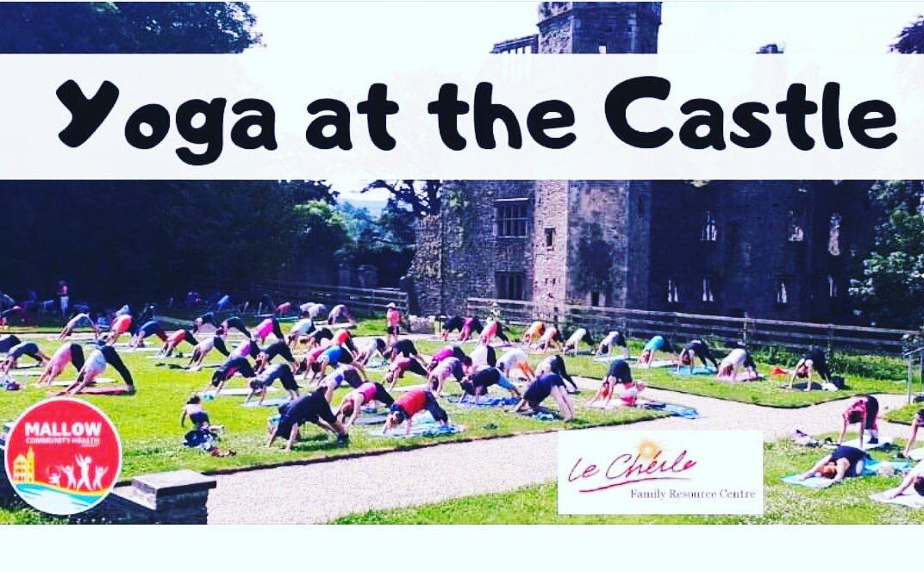

Cork North Community Work Department
Health Action Zone & Community Health Projects
Get Active ~ Get Connected
Mallow Community Health Project
October Community Health Month 2022
Working together to improve the health and lifestyle of a community through a series of health focused initiatives

TO REGISTER FOR THIS EVENT: CONTACT MALLOW COMMUNITY HEALTH WORKER
Pauline O Grady-Noonan (087)4335047 or email chp@lrcheilefrc.ie

